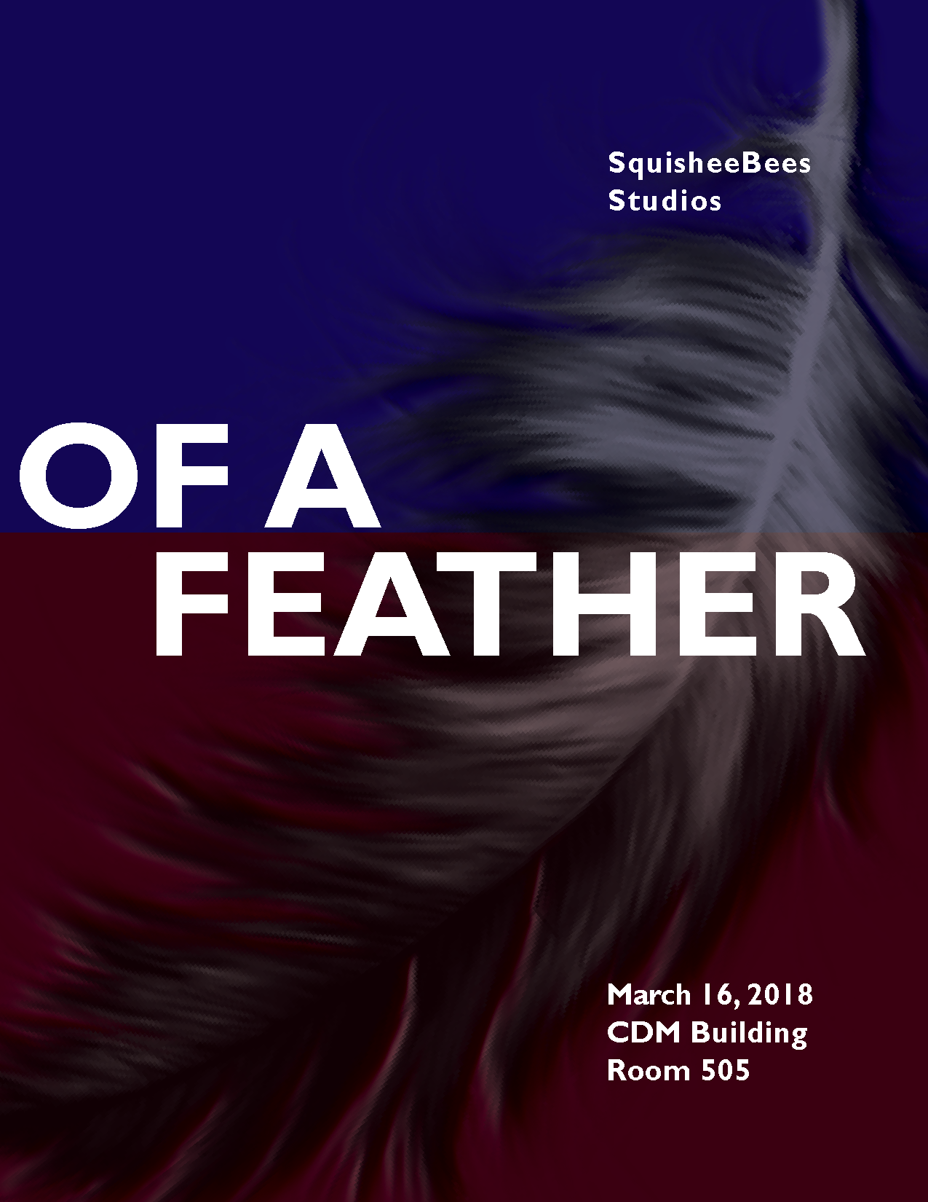

**1. Game Overview**

As a twenty-year old female revisiting her family’s basement, you begin reminiscing of your childhood and the struggles that ensued as a result of being diagnosed with bipolar disorder at an early age. Different objects and reflections within the basement send you back to significant events in your life that help you realize how important friendship is, but even more importantly, the necessity of finding your way through the darkness in order to realize that there is not better you than the real you.

**1.1. Game Concept**

*Of a Feather* is a deep game that works to evoke emotions and physical impairments that are the direct result of living with a mental disorder, such as Bipolar. As the player reflects on his/her own life, they are reminded of the hardship that existed before realizing they don’t have to fight it alone. With the comfort of finding a friend to help during difficult times, *Of a Feather* also works demonstrate that one cannot solely rely on others, but must find comfort in one’s self in order to truly learn how to live with any disorder or hardships.

**1.2. Genre**

Rhythm / Explorative Narrative

**1.3. Target Audience**

The main audience is both male and female, age ranging from 18-30. Although younger ages can see the appeal of the realistic strain on friendships, older ages are more adept to the memory of lasting friendships evolving with age.

Regardless of the players’ age, we hope to attract a large range of players through the conveyance of the underlying message.

|  |  |
| --- | --- |
| Audience: | 18- 30 |
| Genre: | Rhythm / Explorative Narrative |
| Platform: | PC |
| Property: |  |
| Expected ESRB Rating: | T |

**1.4. Game Flow Summary** – How does the player move through the game. Both through framing interface and the game itself.

The player begins in present time, age twenty-four, descending down the stairs into their parent's three-dimensional basement. Upon entering the basement, the player will be capable of free-movement throughout the basement. Once the player comes into contact with a photoalbum, a trigger will activate, transforming the basement to its current state fourteen years prior, when the player was ten years old. This basement state will possess different objects from the present day basement to reflect the backwards travel through time.

Again, the player will have flexible maneuverability within the basement. Once the player comes into contact with a mirror, they will then be transported into a two-dimensional world located on pages of notebook paper. This two-dimensional space is designed by taking an artist doodle approach, where the environment is a dance studio, where the player is intermixed with other classmates. This scene is the first of four minigames represented within the game. The game switches between the three-dimensional basement and the two-dimensional mini games, ending back in the three-dimensional basement.

**1.5. Look and Feel** – What is the basic look and feel of the game? What is the visual style?

*Of a Feather* is composed of two style types: 2D and 3D

2D: The two-dimensional environment is reserved for all the minigames, which will take on the appearance of doodles within a sketchbook. This visual style is purposeful for sketching and writing in notebooks is a way for many to escape from reality and express their feelings. Therefore, since the minigames are made with the intent to provoke emotional interests from the player, it seemed only appropriate to provide these emotions on a medium that is so commonly used to provoke feelings across a large array and disorders and mental disabilities.

3D: The three-dimensional environment works as the physical representations that coincides with the mental representations of the two-dimensional space. To further elaborate, the three-dimensional space will take the form of a family basement with several objects working to evoke memories that trigger the two-dimensional gameplay. Therefore, the three-dimensional space will work to provide the player with personal insight to the physical drain that impacts a person living with a mental disorder, as well as acts as a player hub, allowing the player time to make sense of the emotions felt within the two-dimensional space.

**2. Gameplay and Mechanics**

**2.1. Gameplay**

*Of a Feather* consist of two different gameplay genres; exploration and rhythm. The game is divided into three-dimensional (exploration) and two-dimension (rhythm) artistic flows that alternate as the player progresses through the game. Within the three-dimensional space, the player is able to explore freely throughout the basement space and interact with several objects within the environment. The player needs to explore this area in order to obtain the object that triggers the the beginning of one of the four minigames.

The two-dimensional space is reserved for the minigames, and presents itself as a ballet environment doodled out on notebook paper. Within this two-dimensional space, the player must interact with arrow keys on the keyboard to keep up with the rhythm presented within the ballet scene.

**2.1.1. Game Progression**

*Of a Feather* presents a linear style of gameplay progression, meaning the player doesn’t have options on how they progress through the game. Instead, the player is lead through trigger interactions from an alternating three-dimensional and two-dimensional environments, each maintaining different gameplay mechanics to further the game’s progression.

As the player progresses through the game, they experience different ups and downs presented through living with bipolar disorder. This also applies to the telling of the friendship, as a player does not need to know of mental illness in order to experience from this game. Our aim to make an experience that is open-ended and is relatable to anyone, regardless if they are living with a mental illness.

**2.1.2. Mission/challenge Structure**

The goal of the game is for the player to realize that no matter what struggles are present throughout life, there is always a way through the darkness, but in order to make it through you must find your own path. There will be people to help you through your struggles and darkness, but it is still your own path.

**2.1.4. Objectives** – What are the objectives of the game?

The game is structured with the purpose of reflecting feelings of loneliness, frustration, anxiety, and depression. These emotions will be captured through the gameplay mechanics and the result of each action the player enforces.

**2.1.5. Play Flow** – How does the game flow for the game player

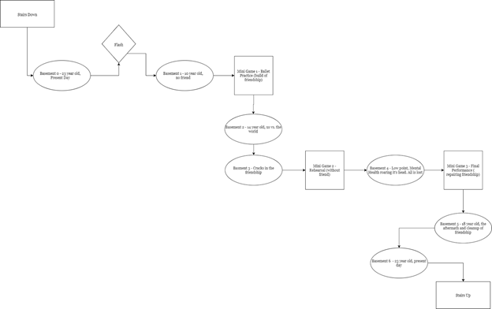

In between the mini games and basement scenes are fade in/fade out moments. These fades are color by fading into the mini game with black, and fading back into the three-dimensional basement with white.

**2.2. Mechanics** – What are the rules to the game, both implicit and explicit. This is the model of the universe that the game works under. Think of it as a simulation of a world, how do all the pieces interact? This actually can be a very large section.

Each 2-D game is at its core a rhythm game, based on arrow presses. Each mini game has slightly different pushing a slightly different mood in a major unifying story theme.

1. Practice: Loneliness to Us vs. the World
2. Rehearsal: Chaos, Fear & anxiety, loss of control
3. Dark: Confusion, Fear, Frustration, Apprehension, Self-growth
4. Performance: Reconnecting, excitement, & reprise of Us Vs. the World

In each 3-D basement environment the player can move about, pick up objects, listen/read the story through each item picked up and activate the mini-games. The basement environments reinforce the moods of the 2D mini games around it by providing more context to the metaphor of the 2D games.

Practice is where the main character is in a ballet class and having issues following the class. This is done when the player tries to press the arrow that corresponds to the class arrow and the player character is a step behind the class. Then your friend joins in. The player has a new arrow to follow. When the player follows the new arrow, the player character matches up and is in sync with the friend. This occurs until the game ends (in best case scenario).

Rehearsal is the game where your friend is gone and there is no way to win. A player’s fingers should get tangled as they try to keep up with the pace of the class arrow. However, like in Practice, following the class arrow doesn’t help you, the player. The wrong note continues to play, the spotlight gets brighter and the surrounding area not in the spotlight gets darker. All while the class leaves the stage. The player character falls as you “fail”.

Dark is the game where you are trying to learn how to make your own arrows and dance moves to follow. This happens slowly and the player moves around a dark and confusing level where the main point of light is an open door at the opposite end of the level from the start.

Performance is the last mini-game of the whole game and it is the game where you rejoin your friend on stage. Now, the player has their own arrows along with the friend’s so the player can chose to follow their own arrow or sync up with their friend. This is where there can be a longer play time, where a score can be implemented if we want. This is where the metaphor can take on more of a gamified idea on top of the feedbacks of particle effects, visuals and sound, if the team and playtesting dictates.

**2.2.1. Physics** – How does the physical universe work?

Physics will only be prominent within the three-dimensional environment. The physics complexity will be kept at a minimal, and only relevant to pick up objects throughout the basement scenes.

**2.2.2. Movement in the game**

Movement will only be relevant within the three-dimensional space, and only used to maneuver the player around the basement scenes.

The movement mechanics will be controlled with a combination of mouse and key presses. To control the orientation of the player character, the player will drag the mouse across the screen with the player character following the mouse’s direction. Keyboard inputs “A” “D” “W” and “S” will be used to move the player left, right, forward, and backward.

**2.2.3. Objects** – how to pick them up and move them

Once the player comes into contact with the collision box of an element, kept within a close approximation of its parent object, the player will have the option to “left” mouse click to pickup the object, using a master code that sees if the player character is close to the object, and if the “crosshairs” are on it, when they left click, the object is lifted up. To put the object down, the player again will “left” click the mouse, resulting in the object being dropped, thanks to it’s rigidbody.

**2.2.4. Actions, including whatever switches and buttons are used, interacting with objects, and what means of communication are used**

**Three-dimensional environment**

The three-dimensional basement environment allows for the player to use both the mouse, as well as keyboard inputs, to maneuver and interact with the surrounding objects. Within this space, the player has free control to move about the room using a combination of “A” “W” “D” “S” to control the translation of the player, as well as mouse movements to control the orientation of the player.

To interact with objects within the three-dimensional basement scenes, the player is prompted to “left” click the mouse the pick objects up, and again “left” click to drop objects.

Maneuvering through the basement and picking up/ putting down objects are the only actions presented within the three-dimensional basement scenes, therefore no other controls are required.

**Two-dimensional environment**

Each of the four two-dimensional environments, or mini games, will be dressed as ballet practice, ballet rehearsal, dark room, and the final performance. The mechanics of each two-dimensional room will stay consistent, only requiring the player to use the arrow key inputs on the keyboard. Arrow key inputs allow the player to perform different stationary dance moves, with each dance move being called by an arrow control presented on screen, demonstrating to the player when each arrow should be executed. Since the dance moves remain stationary, the player will not have further maneuverability throughout the space, so no additional inputs are needed.

Within these two-dimensional rooms, the player had control over which arrow inputs are selected, but the player does not have control over the specific dance move being performed as the result of the arrow input selected. The following action will instead be determined by *Of a Feather*’s underlying code to provide the developers full control over the gameplay to help further provoking different moods from the player.

**2.2.7. Screenflow** -- A graphical description of how each screen is related to every other and a description of the purpose of each screen.  
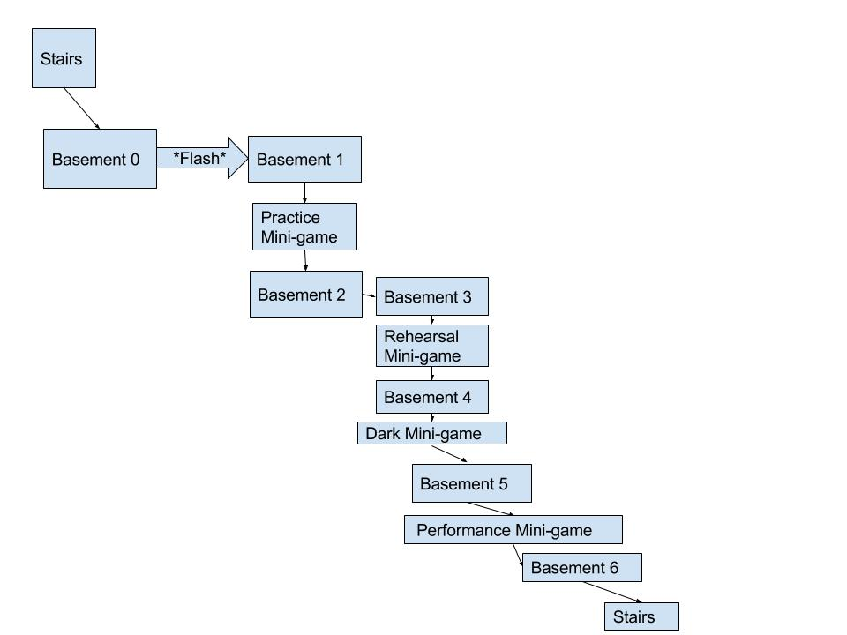

**2.3. Game Options** – What are the options and how do they affect gameplay and mechanics?

*Of a Feather* is a game meant to provoke the player to feel certain emotions that connect them on a deeper level to the symbolism behind the game. Therefore, to keep control of the emotional context from scene to scene, the player will follow a linear style of play, resulting in no decision making that will affect the flow of the game.

Menu Options:

* Subtitles: On -and- Off
* Pause screen
* *Save progress - TBD*
* Quit

2.5. Cheats and Easter Eggs

Dumpy Dan  
Gingerbread Man  
Kelly’s Art - TBA  
JAWBREAKERS!!!!!!!

**3. Story, Setting and Character**

**3.1. Story and Narrative** – Includes backstory, plot elements, game progression, and cut scenes. Cut scenes descriptions include the actors, the setting, and the storyboard or script.

The story here is a girl who is growing up while also having her world rocked by mental illness, having a close friend they rely on heavily ripped away by time and circumstance and feeling alone in a world.

**3.2. Game World**

**3.2.1. General look and feel of world**

The game is broken up into two alternating art styles, two-dimensional and three-dimensional:

**Three-dimensional (basement)**

The three-dimensional basement will have a low-poly but realistic feel designed to separate the player from the minigame environment, giving space to not only further the emotion interest, but also to provide time to reflect on the feelings being provoked throughout the whole of the game; ideally giving the player time to capture the emotions and apply them to their own experiences.

This three-dimensional space will take the appearance of a family’s finished basement, with objects and furniture evolving through time and story with the player. The purpose of this is to not only further identify where the player is within their memory timeline, but also help to add more to player’s connection with the story’s progression itself.

**Two-dimensional (minigames)**

The two-dimension minigames will represent either ballet practice, ballet rehearsal, a dark room, and finally a ballet rehearsal. These rooms are dressed to appear as doodles on notebook paper, allowing for the player to focus on their actions when interacting with the keyboard inputs, and the following result of those actions. This way the player is not distracted with the background environment, but instead focused on the player character and subtle events occurring around them, which will make it possible for designers to provoke specific emotions within specific minigames.

3.2.2. Areas, including the general description and physical characteristics as well as how it relates to the rest of the world (what levels use it, how it connects to other areas)

The practice room, dark room and stage are all two dimensional notebook environments that are where each mini-game takes place.

The Basements are all 3D environments that vary over the progression of the game due to the stage of the game and what mood the game is trying to present at that specific point of the game. These moods are focused around the moods of the minigames and are used to support them.

**3.3. Characters.** Each character should include the backstory, personality, appearance, animations, abilities, relevance to the story and relationship to other characters

Player Character (Cori) - Has a Bun in all the mini-games. Has a bipolar breakdown mid-game. Low point (basement 4). Less graceful than she thinks she is and by the end should have some wacky dance moves.

Friend Character (Kelly) - Has ponytail in all the mini-game. Precise, accurate but has the ability to be silly at times. Artistic, creative and usually (at least outwardly) confident. BPD and anxiety. Knows how to be herself.

**4. Levels**

**4.1. Levels.** Each level should include a synopsis, the required introductory material (and how it is provided), the objectives, and the details of what happens in the level. Depending on the game, this may include the physical description of the map, the critical path that the player needs to take, and what encounters are important or incidental.

* Basement 0 - The first basement you find when you walk down the stairs. Player is currently an adult, so it is full and bright and the mood seems optimistic and stable. There are some areas that look as if it could use some constructive help, but it looks in stable shape.
* Basement 1 - The basement when the player was a young child. It is mostly empty with fewer interactable items and more ambient noise to add to the cold feeling. The items that the player does have tell a story of the player enjoying them, but feeling alone.
* Practice - A friend has arrived and makes a way into this world of the player character’s where the player feels they they are always faltering. This creates this us against the world mentality.
* Basement 2 - Us vs the World is continued. Inside jokes go here and Player seems happier. “Someone gets me. Someone really gets me.”
* Basement 3 - “Oh….I’m doing something wrong… Am I not spending enough time with her? Did I say something wrong?” Growing pains. The two friends grow apart over time the closer they get to college.
* Rehearsal - Crash. Your friend is gone. You are alone and you weren’t expecting it. Everything is hard and horrible to keep up with now.
* Basement 4 - Homework and books everywhere. A pill bottle in the corner. Broken mirror. The basement is a complete mess. There is a hole in the wall. You may be able to see outside. The mood is dark. This is the height of the illness, when it is completely out of control.
* Dark - A dark room in the game where the player has to create their own controls to escape out the one lit door
* Basement 5 - Player is doing a bit better now. Hole is fixed. Writing now reflects things about working and living back at home and trying to survive.
* Performance - The player has reunited with the friend and now the player can choose to dance in their own way or in their friends.
* Basement 6 - Basement 6 == Basement 0. Just now the player has time to explore it. This is how the player can “revisit” everything that was found in the other basements.

4.2. Training Level - Not Available. The game teaches and trains you how to play as the game progresses.

**5. Interface**

**5.1. Visual System.**  Basic crosshair, for aiming to pick up things. Menus will be exclusively on pause and main menu.

**5.2. Control System** – Use WASD to move in the 3D, left click to pick up things/drop things, arrow keys to move in 2D scenes. Escape is pause.

**5.3. Audio, music, sound effects**

**Three-Dimensional Basement**

This area has several audio components; voice, ambient, and misc sound effects. Voiceover is used when a player picks up an object, and a memory plays tied to that object. This is to create the story that the player will need to understand what is going in the mini games presented. Ambient noises and tracks are used to immerse the players, and are used at a lower volume, with minimal tones to reduce pollution. Lastly, sound effects are much like ambient noise, but are used at specific moments to enforce the memories, and emotions this game is conveying.

**Two-Dimensional Mini Games**

The focus for the audio in the mini games are to illicit notifications for the player to know what they are doing. For instance, in the first mini game, the player hears a wrong note every time they hit a wrong arrow key. This goes on until the friend joins, where sound is played to notify the player someone has arrived. From then on, the player chooses between following the friend, where a correct note sound plays, or following the class, where the same wrong note sound plays.

In addition to these sounds, a piano melody will play, telling the tale through music. Each mini game is tied to different emotions, and thus, the piano melody adjusts accordingly. These melodies are simple, but effective (hopefully).

6. Artificial Intelligence

**7. Technical**

**7.1. Target Hardware**

Target platform is PC

**7.2. Development hardware and software, including Game Engine**

**Game Engine:** Unity

**Modeling Software:** Maya, Blender, Adobe Photoshop

**Texturing Software:** Substance Painter

**Versioning Software:** GitHub

**8. Game Art –** Key assets, how they are being developed. Intended style.

Key Assets for three-dimensional realistic space (basement):

* Ballet shoes -maya
* Notebooks -maya
* Photo Album - maya
* Prescription bottle- maya

Key Assets for two-dimensional doodled space (minigames)

* Arrow controls -photoshop
* Player character -photoshop